

Fuel Pulse Dampers (Direct Mount)

Part Number | Description
25-4002 | Direct Mount -6 ORB Standard Range (40-70 PSI)
25-4004 | Direct Mount -6 ORB Extended Range (40-100 PSI)

CAUTION: It is imperative that extreme caution be taken when working with the fuel system. Do not smoke or expose the working area to any spark or flame. Work in a well-ventilated area. Clean up any spilled fuel immediately and dispose cleaning materials in a sealed metal trash container. To prevent premature failure, all O-rings MUST be lubricated prior to assembly.
CAUTION: The fuel system is under pressure! Be sure to relieve the fuel system pressure before loosening any connections. If necessary, consult a service manual for instructions on how to relieve fuel pressure safely.
CAUTION: These products are designed for off-highway and racing use only. Fuel system components may not be legal for sale or for use on emissions-controlled vehicles. Please consult local, state, and federal laws.

- THESE PRODUCTS ARE NOT TO BE USED ON THE LOW-PRESSURE SIDE OF THE FUEL SYSTEM.

Kit Contents:

- Direct Mount Dampers (25-4002 – 25-4004)

  - 1 FT of 5/32 Vacuum Hose
  - 5/32 Nylon Wye

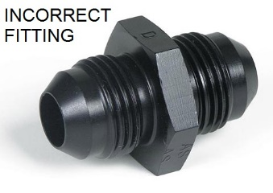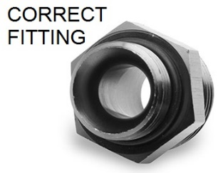

Note on Vacuum Referencing:

** Your base fuel pressure for the model being purchased must lie within the pressure ranges listed above per model. **

- If total fuel pressure (base + boost/vacuum) is within the pressure range for the model being purchased, then vacuum referencing the damper is optional. If the vacuum port is not used, be sure that after installation it is not pointing to hot components such as the engine or exhaust system. If it is, it is HIGHLY recommended that the cap be clocked so that it points away from these components.

- If total fuel pressure (base + boost/vacuum) is outside of the pressure range for the model being purchased, then vacuum referencing is required.

General notes:

- Fuel pulse dampers are mainly used to dampen the local pressure drops/spikes associated with injectors opening and closing. For this reason, the closer you can mount the damper to the source of these pulsations (i.e. Fuel Rail), the better.

- The damper cap can be clocked to an alternate location, if necessary. Pay close attention to the diaphragm and make sure that it is seated properly before reassembling. Diaphragm damage from reassembly error voids the warranty. Torque screws to 40-45 in./lbs. in an alternating pattern.

- Lubricate all O-rings before assembly ideally with an O-ring lubricant.

AEM Performance Electronics
2205 126th Street Unit A, Hawthorne, CA. 90250
Phone: (310) 484-2322 Fax: (310) 484-0152
http://www.aemelectronics.com

